PnP SPFx Yeoman generator

This Yeoman generator provides improved governance for SharePoint Framework projects. It extends the out of the box Yeoman generator from Microsoft (@microsoft/generator-sharepoint) with recommended patterns and additional capabilities.

For an optimized development workflow, it extends the capabilities for ReactJS, and Knockout projects and support for additional frameworks, such as HandlebarsJS, VueJS and Angular Elements. It also includes includes advanced code analysis and testing tools, which you can take advantage of in your development work.

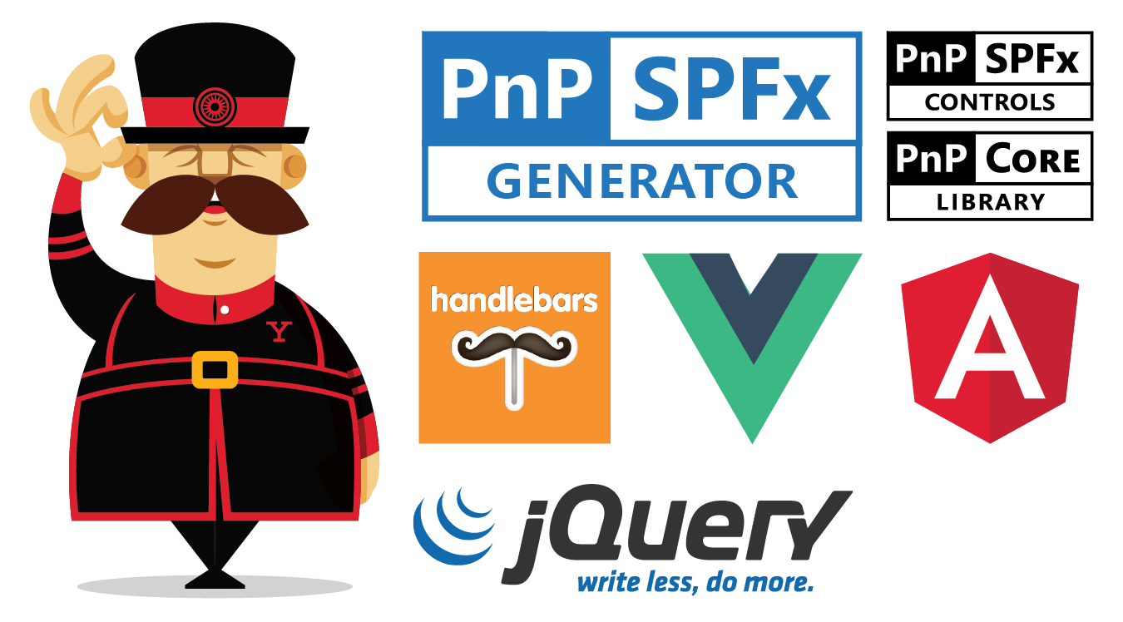

All projects generated by this generator are 100% compliant with the out-of-the-box Yeoman generator from Microsoft. After the creation of a new solution, you can use either this generator or @microsoft/generator-sharepoint to add additional assets to your solution.

SPFx Generator Version

| Base Generator |  |
| --- | --- |
| @microsoft/generator-sharepoint | 1.9.1 |

Features

This generator supports a variaty of of frameworks and features such as:

* VueJS
* Handlebars
* Angular Elements
* Addons such as JEST, StyleLint or WebPack Bundle analyser

More on that in the [features section](https://pnp.github.io/generator-spfx/features/).

Installation

**via NPM**

npm install -g @pnp/generator-spfx

Start a new project

To start a new project execute the following command:

yo @pnp/spfx

This will start the PnP SPFx Yeoman generator for a new project that gives you all the options to choose from.